protein_pipeline: A Reproducible Solubility-Aware Protein Redesign Pipeline with Active-Learning-Based AF2 Budget Reduction
Type: Software Paper / Empirical Benchmark Contribution

Abstract
Solubility-oriented protein redesign increasingly depends on multi-stage workflows that combine homology search, MSA-derived residue constraints, structure-based sequence generation, soluble-expression filtering, structure prediction, and novelty analysis. In practice, these stages are often connected by ad hoc scripts, making runs difficult to reproduce, partially rerun, or update when upstream models change. We present protein_pipeline, a stage-aware and artifact-preserving orchestration framework for reproducible solubility-aware protein library design. The system exposes each modelling stage through typed inputs and run-scoped artifacts, enabling safe partial reruns and model replacement without changing downstream analysis.
We use this framework to address the dominant compute bottleneck after SoluProt filtering in ProteinMPNN-driven redesign: repeated AlphaFold2 (AF2) evaluation of candidate sequences. A local active-learning module embeds SoluProt-passing candidates with ESM-2, selects a small diverse AF2-labelled training set using K-means, fits a surrogate model, and sends only the top-ranked candidates to AF2. The frozen statistical benchmark uses 15 CATH test topologies comprising 1,800 SoluProt-scored and 1,766 AF2-scored designs; K-means selection improves cold-start BO uplift by up to 51% over random sampling at N = 5. Ridge, LightGBM, RF, XGBoost, and KNN are statistically tied for pLDDT selection under the main benchmark, while Ridge is strongest for SoluProt-related benchmark metrics. The same artifact parser was then applied to a QC-filtered CATH expansion set of 23 targets comprising 2,737 valid designs, providing a cleaner corpus for model-replacement and re-analysis.
Beyond surrogate selection, a variance decomposition shows that 99.6% of pLDDT variance is explained by target identity rather than ProteinMPNN sampling noise. This shifts the main compute-allocation decision from deeper sequence sampling within a fixed backbone toward early target or backbone triage. Under a four-round orchestration-level budget model, reuse of the active-learning loop reduces projected AF2 calls from 360 to 110 per target, an approximately 3.3x reduction in AF2 GPU time. Two representative completed runs further verified the multi-round path at production scale, evaluating 94 and 49 AF2 records from 8,000 SoluProt-gated candidates for 3RGK and 1LVM, respectively. Together, these results show that a reproducible, model-replaceable pipeline can serve not only as execution infrastructure for soluble protein-library design but also as an empirical platform for deciding where expensive structure-prediction compute should be spent.

1. Introduction
Computational protein design has moved fast in the past three years. ProteinMPNN [1], AlphaFold2 [2], and RFdiffusion established a baseline modular stack, and a next generation of components - LigandMPNN, AlphaFold3, and conformational ensemble models such as BioEmu - is arriving on roughly annual cadence. However, many practical biofoundry campaigns are not unconstrained de novo design problems. They are soluble protein-library redesign problems: starting from a target sequence or scaffold, the operator wants a tractable library of variants that preserves protected residues, respects sequence/structure constraints, improves soluble-expression likelihood, and remains structurally plausible. Earlier structure- and sequence-based redesign systems such as PROSS targeted bacterial expression and stability [9], and solubility-aware AfDesign showed that solubility can be made an explicit design objective rather than a post hoc concern [10]. protein_pipeline is positioned in this redesign setting, not as a universal substitute for specialised binder, enzyme, or fold-generation systems.
Two consequences follow for groups running solubility-aware redesign campaigns at scale. First, analysis code hard-coded to a particular model version goes stale within a year, because each new release ships its own input format, output schema, and evaluation conventions. Second, AF2 or ColabFold structure evaluation [2, 3] is now the dominant GPU cost after inexpensive sequence and solubility filters: a single target can yield thousands of ProteinMPNN variants, and folding every one is rarely justified. The operational question is therefore not only how to generate soluble candidate sequences, but how to decide which candidates deserve expensive structure prediction, in a way that survives the next round of model updates.
The full redesign stack combines mature but heterogeneous components: sequence search, MSA construction, optional backbone or ensemble generation, inverse folding, soluble-expression filtering, structure prediction, and novelty analysis [1-8]. General workflow systems such as RosettaScripts demonstrated the value of composable modelling protocols for non-expert use and reproducible protocol exchange [11]. In current deep-learning-driven design practice, however, many campaigns still remain organised as scripts, notebooks, and service-specific interfaces. This creates three recurring problems. First, provenance becomes fragile: intermediate artifacts, parameter choices, and filtering decisions are difficult to trace after a run finishes. Second, partial reruns are unsafe: changing a downstream solubility threshold may accidentally trigger upstream recomputation, while changing an upstream input may leave stale downstream artifacts in place. Third, model replacement is costly: a new structure predictor, inverse-folding model, or solubility predictor can require substantial changes to the analysis code, even when the scientific question is unchanged.
These failure modes compound across multi-ablation studies. The six ablations reported in Section 4 - selection method, surrogate family, ensemble rule, training-set size, embedding size, and variance source - all read the same frozen benchmark table of 1,766 stored AF2 outputs through the same parser. The same parser and QC rules now also index a larger CATH execution corpus and separate valid ProteinMPNN designs from input-incompatible fallback records, which would not have been feasible to maintain consistently under a script-based workflow.
Active learning is one practical strategy for reducing the AF2 cost after the fast solubility filter has already narrowed the pool. A cheap surrogate can be trained on a small AF2-labelled subset, rank the remaining SoluProt-passing candidates, and reserve AF2 for the surrogate’s top selections. Similar principles underlie recent language-model-guided directed evolution work [12], but several design choices remain unsettled for a modular solubility-oriented redesign pipeline: which surrogate should be used, how the initial labelled set should be selected, how large that labelled set should be, and whether additional sequence sampling within the same target is the best use of compute.
This paper presents protein_pipeline, a reproducible orchestration framework for solubility-aware protein redesign, and uses it to study these compute-allocation questions. The contribution is two-fold. First, we describe a stage-aware pipeline architecture that preserves artifacts under a run identifier, supports controlled partial reruns, exposes a local/static web interface, and keeps model interfaces replaceable. Second, we use the pipeline’s artifacts to benchmark a local active-learning module and to quantify whether design-quality variance is dominated by target identity or by ProteinMPNN sampling noise. The paper is organised around these two levels: Sections 2-3 define the system and benchmark protocol, Section 4 reports the empirical results, Section 5 discusses the operational implications, and Sections 6-7 cover limitations and conclusions.

2. Design Goals and Research Questions
The pipeline is designed around five system goals.
- Reproducible execution. Each run should preserve the original request, stage outputs, status history, and summary artifacts under a stable run identifier.
- Safe partial reruns. Users should be able to rerun downstream stages after threshold or selection changes without recomputing upstream artifacts, while upstream changes should invalidate unsafe reuse.
- Solubility-aware library design. The default workflow should produce sequence libraries that preserve protected residues, pass an explicit soluble-expression filter, and remain structurally plausible.
- Model replacement. External models should be accessed through typed inputs and run-scoped artifact contracts so that a structure predictor, inverse-folding model, or filtering model can be replaced without rewriting the benchmark code.
- Compute-aware evaluation. Expensive stages, especially AF2, should be invoked only after cheaper signals have filtered or ranked candidates.
The empirical part of the paper asks four corresponding questions.
- Q1 - Surrogate choice after solubility filtering. Among common regression and ranking models trained on ESM-2 embeddings, which surrogate best prioritises SoluProt-passing candidates for AF2 evaluation?
- Q2 - Training-set selection. Given a fixed AF2 budget for initial labelling, does K-means diversity sampling improve surrogate quality over random sampling, especially at small N?
- Q3 - Variance source. Across CATH test topologies, how much of the observed pLDDT and SoluProt variance is attributable to target identity rather than ProteinMPNN sampling noise?
- Q4 - Model replacement. Can the same benchmark protocol be rerun when the structure predictor or inverse-folding model changes?

3. System and Methods

3.1 Solubility-Aware Stage Architecture
protein_pipeline organises a solubility-aware redesign campaign as a stage-aware run rather than as a collection of disconnected jobs. The canonical stage order is:
msa -> rfd3 -> bioemu -> design -> soluprot -> af2 -> novelty
This core ordering is dependency-driven rather than cost-driven. MSA construction must run first because per-position conservation, and the 30%/50%/70% identity tiers used to bound how much sequence latitude each ProteinMPNN run is given, are computed from the alignment. Before design, an internal mask-consensus routine can aggregate programmatic signals - MSA conservation, ligand proximity, MSA quality, and query-PDB identity - into per-tier consensus positions. By default this output is written as an advisory artifact; when mask_consensus_apply=true, the consensus positions are used by the design stage. Manual residue selections from the user interface enter through a separate fixed_positions_extra channel and are unioned into the final fixed-position set used for ProteinMPNN (Section 3.2).
The implementation follows a Model Context Protocol-style separation between tool interface and model backend [13], so individual stages - the masking source, the inverse-folding model, the soluble-expression filter, the structure predictor, the relax backend - can be enabled, disabled, or replaced from the request without rewriting the analysis code. RFdiffusion and BioEmu occupy optional hooks after MSA and provide backbone-topology and conformational diversification [5, 6]; they generate the structures on which ProteinMPNN operates and can be enabled or disabled independently of the masking flow. ProteinMPNN then generates candidate sequences once per conservation tier under the active fixed_positions constraint [1]. SoluProt is the default fast soluble-expression gate before AF2 [7]; AF2 or ColabFold supplies pLDDT-based structural confidence on the surviving sequences [2, 3]. Novelty analysis then compares the surviving designs against a reference database with MMseqs2 [8]. An optional Rosetta Relax post-processing step (off by default, controlled by relax_enabled) refines AF2 outputs and returns per-residue energy scores that contribute a relax-penalty term to the composite design score [14]. The cost-aware property of this order - cheap soluble-expression and sequence-level signals before expensive structure prediction - follows from these dependencies rather than driving them.
Each run writes request metadata, intermediate outputs, status records, and final summaries under a run-scoped artifact directory. The run identifier is the unit of provenance. This structure supports controlled partial reruns: downstream filtering or evaluation can be repeated when only downstream parameters change, while unsafe reuse is blocked when upstream inputs differ. The same artifact contract is used by the benchmark scripts, so the empirical analyses can be rerun from stored outputs rather than from live model calls.

3.2 Diversification and Constraint Handling
The pipeline exposes three sources of candidate diversity before AF2 is invoked (Figure 1). RFdiffusion provides topology-level backbone diversification. BioEmu samples conformational frames around a backbone. MSA-derived conservation tiers fix progressively larger sets of conserved positions during ProteinMPNN design, producing sequence pools with different redesign latitude. Together, these stages separate across-backbone exploration from within-backbone sequence sampling, which becomes important for interpreting the variance decomposition in Section 4.7.
Residue protection has two paths into the design stage. (i) Mask consensus aggregates programmatic signals - MSA conservation, ligand proximity to non-water hetero atoms, MSA quality, and query-PDB identity - into per-tier consensus positions and writes them to mask_consensus.json. Unless mask_consensus_apply=true, these positions remain advisory and the design stage continues from the MSA-derived conservation tiers. When consensus application is enabled, the consensus positions become the tier-specific fixed positions passed into ProteinMPNN. (ii) Manual residue selections from the user interface enter through a separate fixed_positions_extra channel and are unioned into the final per-chain fixed-position set. A Gemini-based agent panel reads the same artifacts and supplies literature-grounded commentary for the operator alongside the run, but does not feed the consensus computation. The design stage therefore sees a single fixed-position structure after the enabled programmatic and manual constraints are merged.
The packaged web interface mirrors this distinction. A basic mode exposes the end-to-end solubility-aware library workflow with a small number of output-size and threshold controls. Advanced mode exposes start and stop points, optional backbone/ensemble stages, masking controls, and AF2 budget parameters. This is included as a static frontend rather than as a required hosted service, so a user can run the backend on a local workstation or GPU server while serving the UI locally.
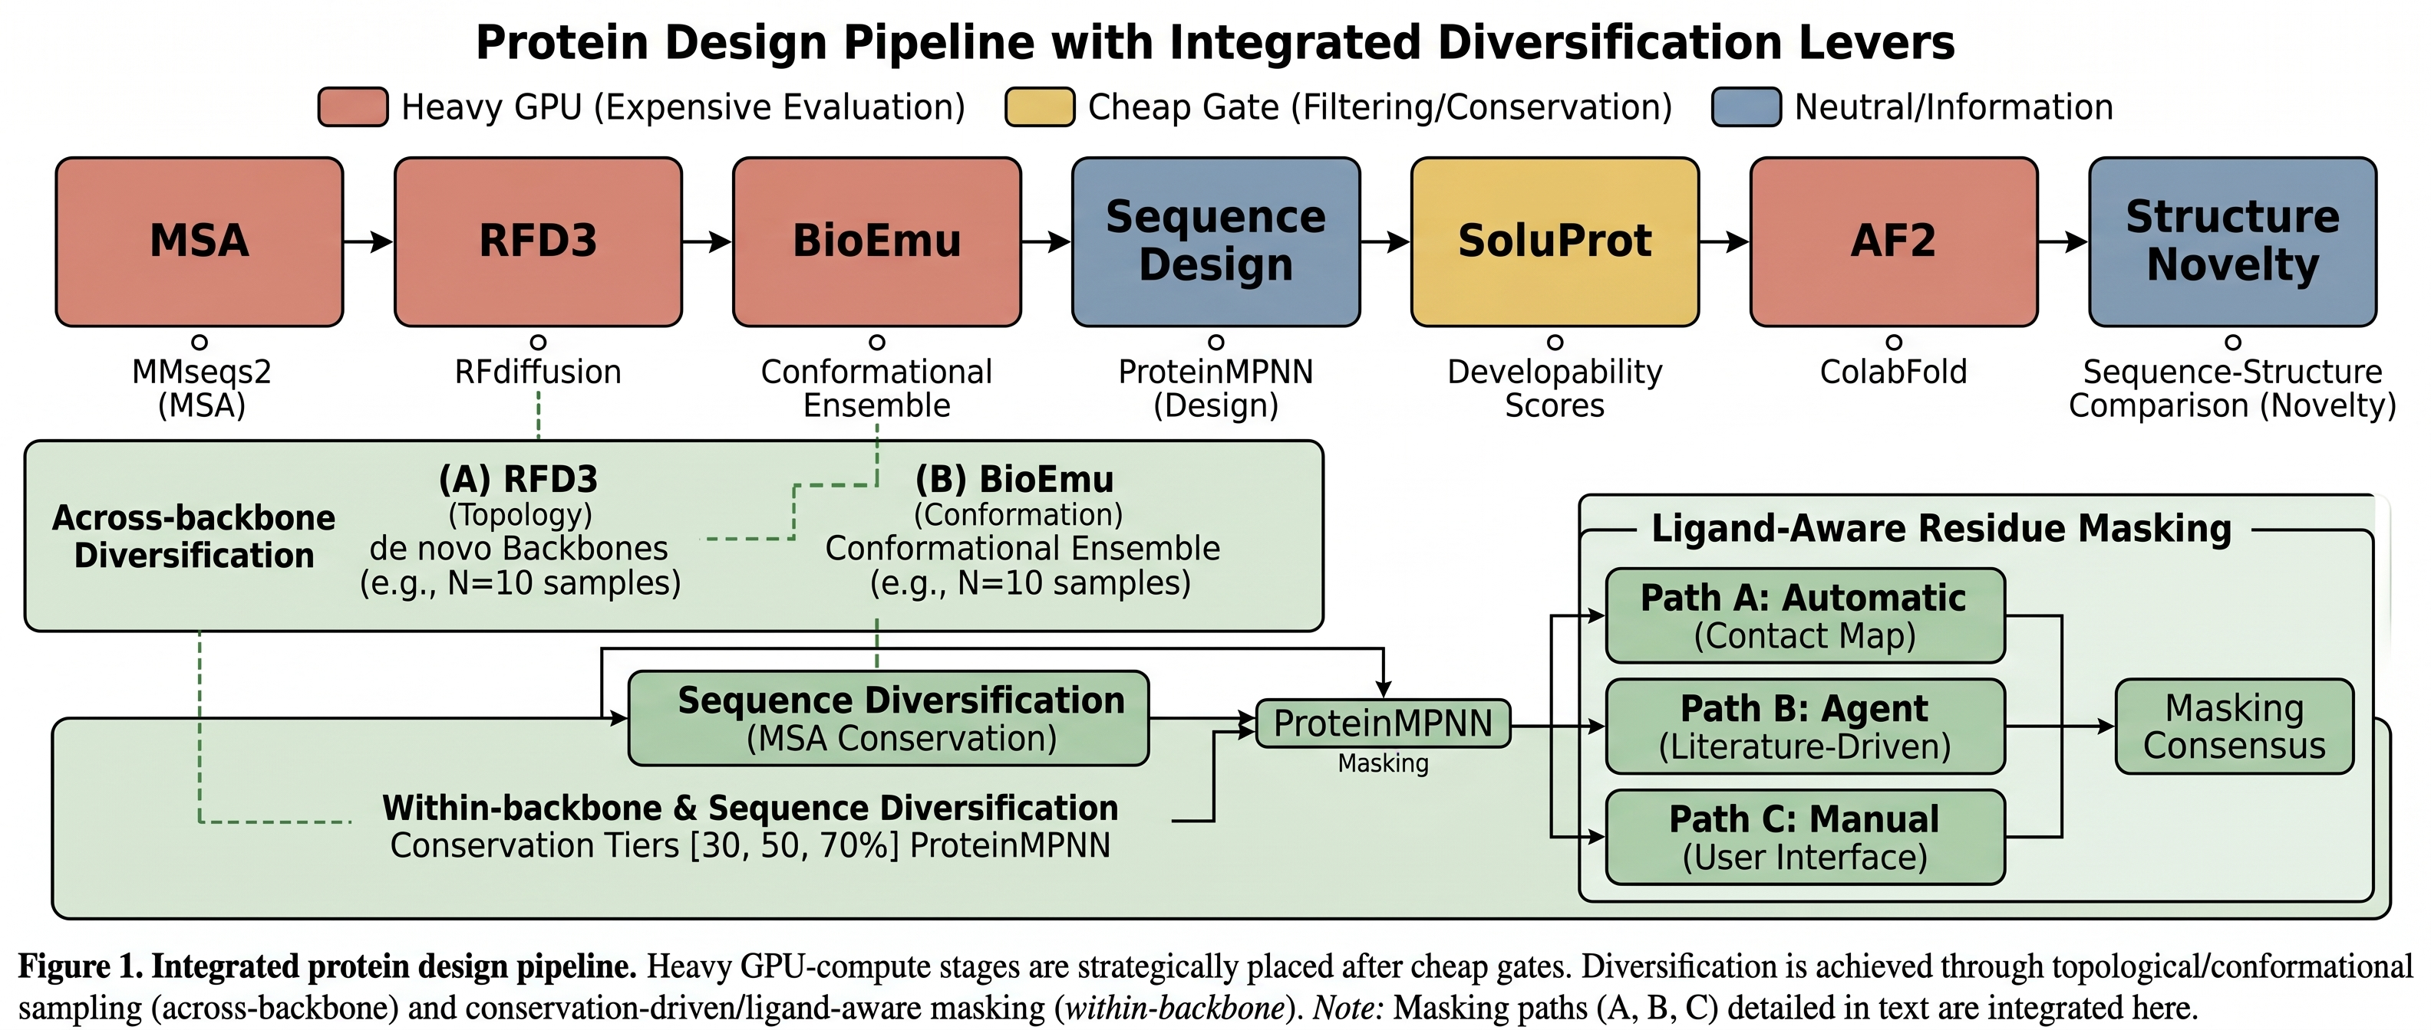
Pipeline overview
Figure 1. Stage order and diversification levers in protein_pipeline. The default path is a solubility-aware redesign workflow: MSA-derived constraints guide ProteinMPNN sequence generation, SoluProt filters candidate soluble-expression likelihood, and AF2/ColabFold is reserved for structurally plausible short lists. RFdiffusion and BioEmu diversify backbone topology and conformation, conservation tiers diversify sequences within a backbone, and ligand-aware masking can protect residues that should not be redesigned.

3.3 Active-Learning Module for AF2 Reduction
The active-learning module supports a multi-round orchestration mode within one pipeline invocation (Figure 2). Round 1 bootstraps a local surrogate from a K-means-selected AF2-labelled training set; subsequent rounds generate new candidate pools, reuse the archived local expert, and send only the surrogate-ranked Top-K candidates to AF2. The benchmark below validates the component choices from stored candidate pools; Section 4.8 reports two completed representative multi-round runs to verify the implemented orchestration path, while leaving broad campaign-level hit-rate estimation to future work.
The loop has six steps. First, ProteinMPNN generates a candidate pool across conservation tiers, and SoluProt scores every candidate. Second, candidates passing the SoluProt gate are embedded with mean-pooled ESM-2 8M embeddings [4], and K-means selects a diverse initial training set. Third, AF2 evaluates the selected training candidates. Fourth, a local surrogate is trained on the AF2-labelled examples and ranks the unlabelled SoluProt-passing pool by predicted pLDDT. Fifth, AF2 evaluates the surrogate’s top-ranked candidates. Sixth, the evaluated set is ranked by a composite score combining observed pLDDT, directly observed SoluProt, and an optional relax penalty [14].
At the production defaults, the first round evaluates 30 K-means-selected training candidates and 20 surrogate-selected candidates, for approximately 50 AF2 calls. Later rounds reuse the local expert and evaluate only 20 surrogate-selected candidates per round. Evaluating every candidate in a 90-candidate SoluProt-gated pool would require approximately 90 AF2 calls per round.
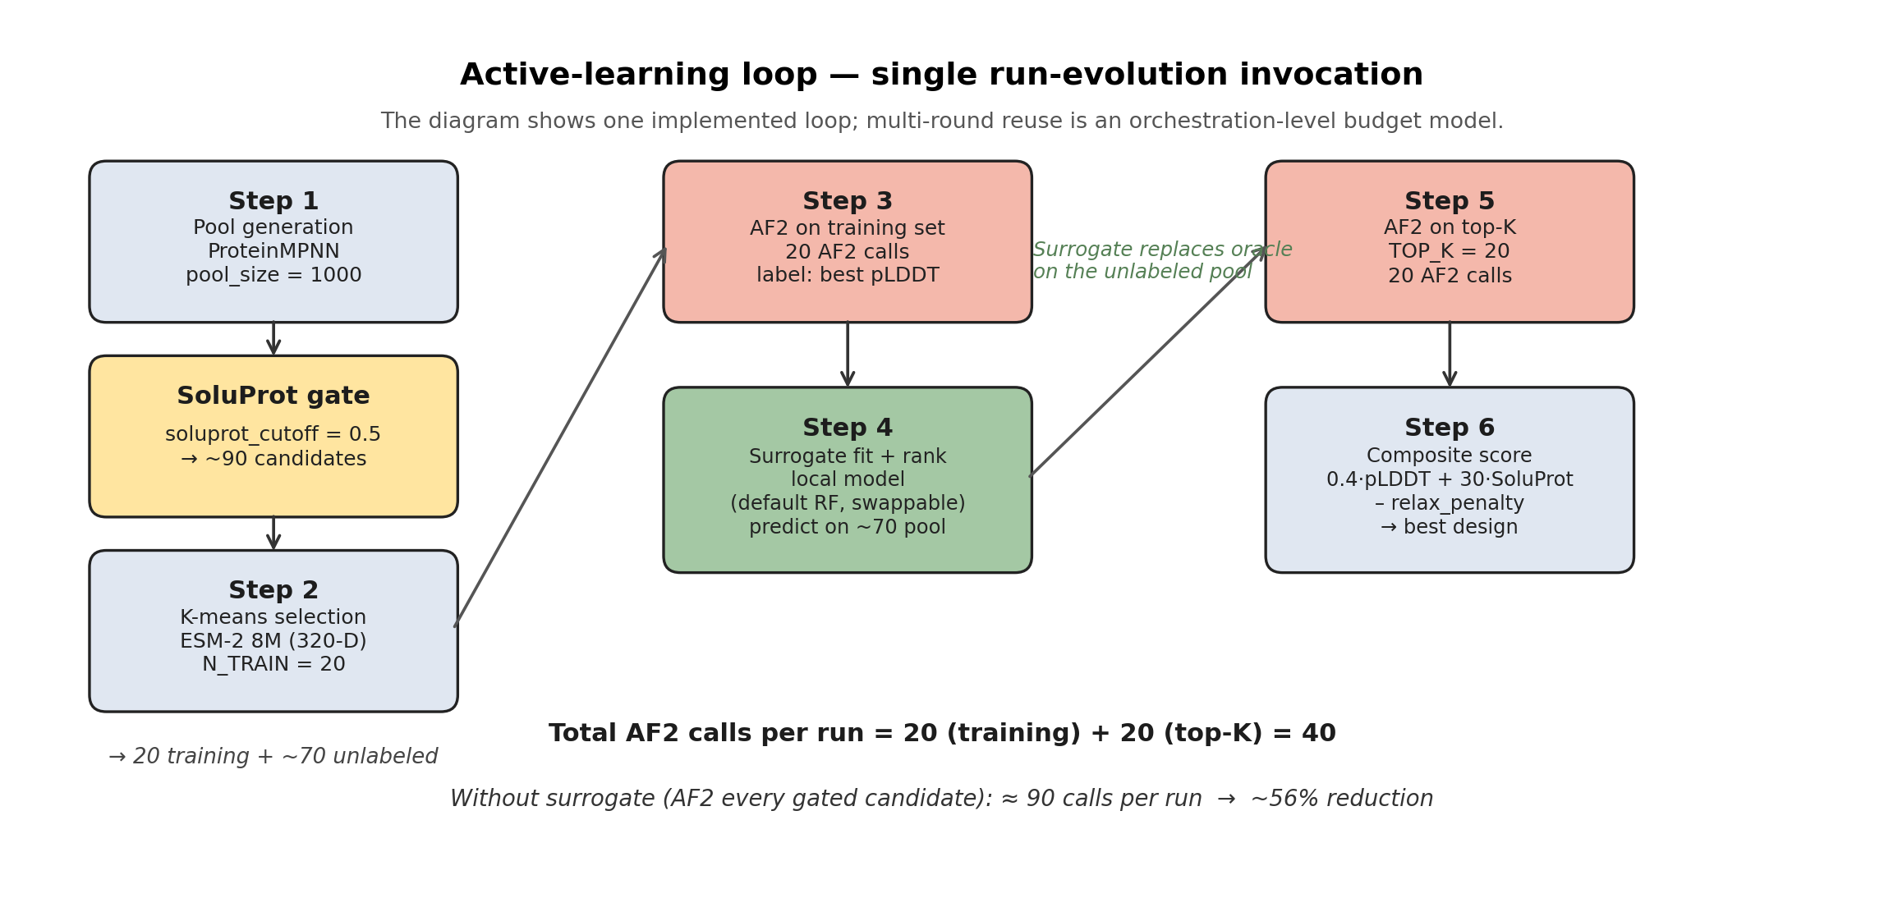
Active-learning loop
Figure 2. Active-learning loop used to reduce AF2 calls. A small K-means-selected training set is labelled by AF2, a local surrogate ranks the remaining pool, and AF2 is reserved for the surrogate’s top-ranked candidates. In multi-round mode, this local expert is reused on later candidate pools so that only Top-K candidates are folded after the bootstrap round.

3.4 Benchmark Dataset and Surrogates
The statistical benchmark uses a frozen subset of 15 CATH [15] test topologies. For each target, ProteinMPNN generates 120 designs across three conservation tiers, yielding 1,800 SoluProt-scored designs and 1,766 designs with usable AF2 outputs. All surrogates consume mean-pooled ESM-2 8M embeddings (320 dimensions) [4]. After the benchmark was frozen, we curated an additional CATH expansion set by applying automated QC to the completed execution archive. Runs whose designs.fasta/designs_filtered.fasta artifacts consisted of fallback identifiers or invalid amino-acid sequences were removed, as were runs with too few positive AF2 confidence records for target-level analysis. The resulting publication-grade expansion subset contains 23 CATH targets and 2,737 valid designs with paired SoluProt and positive pLDDT records. We therefore treat the 15-target table as the locked statistical benchmark for the reported surrogate comparisons, and the 23-target curated archive as the released expansion corpus for rerunning those analyses or testing replacement model backends.
Seven regression surrogates are evaluated against a random baseline: Random Forest [16], Ridge regression, Gaussian Process with RBF kernel, XGBoost [17], LightGBM [18], K-Nearest Neighbours, and a small multilayer perceptron. Implementations come from standard machine-learning libraries [19]. K-means uses k-means++ initialisation [20]. The production evolution loop exposes the benchmark-supported RF, Ridge, LightGBM, XGBoost, and rank-mean ensemble options; GP-RBF, KNN, MLP, and random selection are retained as empirical comparators rather than production defaults.
For each target and seed, a training pool of N candidates is selected either uniformly at random or by K-means cluster centres. The surrogate is trained on that pool and ranks a held-out candidate set. The main model comparison uses N = 30, and the sample-size ablation evaluates N in {5, 10, 20, 30, 50, 80}. The production loop uses N = 30 to match the benchmark default: the N-ablation in Section 4.6 places 20-30 examples on the cost-efficient plateau, so 30 is the largest near-plateau value validated by the main model comparison.

3.5 Metrics and Statistical Analysis
The benchmark reports three metric families. Spearman rho measures rank correlation between predicted and observed scores. Top-K recall measures how many true Top-K candidates are recovered by the surrogate’s predicted Top-K. BO uplift Top-K, following the selection-focused evaluation common in Bayesian optimization [21], measures the difference between the mean observed score of the surrogate-selected Top-K and the mean score of K random draws from the same held-out pool. We use Top-5 as the primary setting because it is the most discriminating short-list regime in a 90-candidate pool.
Paired comparisons use the Wilcoxon signed-rank test [22] with Holm-Bonferroni correction [23]. Effect sizes are reported as Cliff’s delta [24]. Confidence intervals are 95% cluster bootstrap intervals with target as the cluster. Variance decomposition uses the one-way ANOVA-based intraclass correlation coefficient ICC1 [25].

4. Results

4.1 Pipeline Execution Model
The pipeline structure makes execution artifacts reusable for analysis. A run contains the request, stage outputs, status logs, SoluProt scores, AF2 outputs, and final summaries needed to reconstruct the path from input target to selected soluble-design candidate. This matters concretely: every result in Sections 4.2-4.7 below - the K-means versus random ablation, the eight-surrogate comparison, the ensemble study, the bias and diversity analysis, the N- and ESM-size ablations, and the variance decomposition - was computed from the same 1,766 stored AF2 outputs using the same parsing code. No per-ablation re-folding was performed; ESM embeddings were computed once per model size (320-D and 640-D) and reused across all downstream surrogate analyses. No ablation required modifying the artifact schema. The same parser now indexes the CATH expansion archive, and a QC layer retains 23 publication-grade runs under cath_outputs/paper_curated/ without changing the schema. It also matters for model replacement: if a new structure predictor, inverse-folding backend, or solubility model writes the same artifact fields, the benchmark can be rerun with the same analysis protocol.
The expanded CATH archive is therefore reported separately from the frozen statistical benchmark. The curated subset contains 23 targets and 2,737 valid designs. Its mean pLDDT is 91.91, the maximum pLDDT is 97.89, the mean SoluProt score is 0.615, and the maximum SoluProt score is 0.971. These values are derived from the stored run artifacts and summarised in cath_outputs/paper_curated/curated_summary.json. Records excluded by QC are not treated as failed designs; they are treated as input-compatibility or design-generation failures for the current pipeline contract.
The stage order also makes the compute policy explicit. Backbone diversification and sequence generation occur before AF2, while SoluProt acts as a cheap soluble-expression gate. The active-learning module then reduces the number of SoluProt-passing candidates sent to AF2. The remaining results quantify the operating point of this policy.

4.2 Training-Set Selection Improves Small-N Efficiency (Q2)
K-means training-set selection improves Random Forest BO uplift in the small-N regime (Figure 3, Table 1). At N = 5, K-means improves BO uplift by 51% over random sampling; at N = 10, by 49%; and at N = 20, by 21%. The gap closes near N = 30, where random sampling becomes diverse enough by chance, and reopens slightly at larger N.
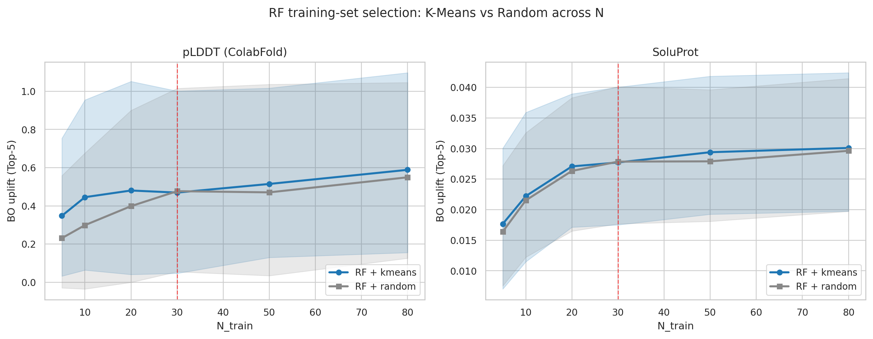
Selection x N
Figure 3. Random Forest BO uplift Top-5 as a function of training-set size N under random and K-means training-set selection. K-means dominates random by +51% at N = 5, +49% at N = 10, and +21% at N = 20; the gap closes near N = 30 where random sampling becomes diverse enough by chance, and re-opens slightly at N >= 50.
N | Random | K-means | Delta (K-means - random)
5 | 0.231 | 0.348 | +0.117 (+51%)
10 | 0.299 | 0.446 | +0.147 (+49%)
20 | 0.399 | 0.481 | +0.082 (+21%)
30 (production and benchmark default) | 0.477 | 0.470 | -0.007 (-1%)
50 | 0.471 | 0.515 | +0.044 (+9%)
80 | 0.550 | 0.589 | +0.039 (+7%)
Table 1. Random versus K-means training-set selection for the production Random Forest surrogate. The K-means advantage is largest precisely in the small-N cold-start regime targeted by the multi-round budget model.
The selection strategy interacts with surrogate family (Figure 4). Tree and linear models benefit most from K-means coverage of the embedding space. GP-RBF and KNN can lose performance under K-means because they rely more directly on local neighbourhood density.
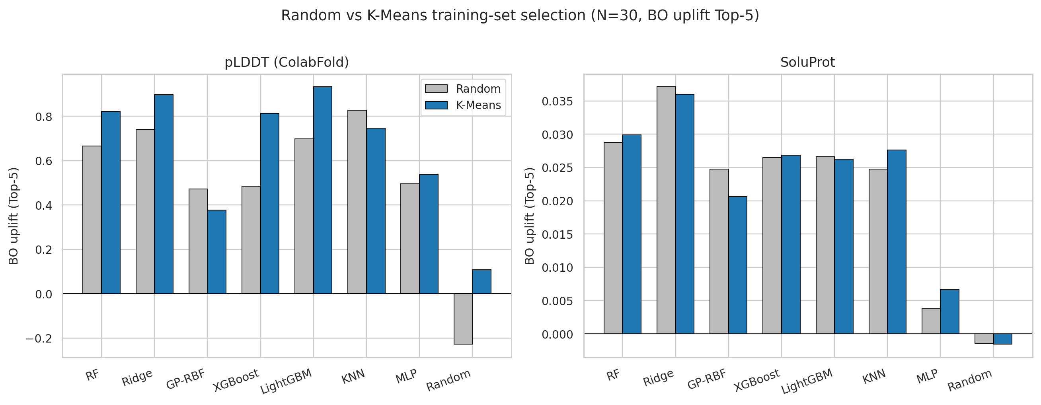
Selection x model
Figure 4. Per-model effect of training-set selection on BO uplift Top-5 at fixed N = 30. Tree- and linear-model families (RF, Ridge, LightGBM, XGBoost) consistently benefit from K-means selection on pLDDT. Locally-dense models (GP-RBF, KNN) are hurt by K-means on pLDDT and are only marginally affected on SoluProt. This asymmetry motivates the production default of pairing K-means selection only with RF, Ridge, LightGBM, or XGBoost surrogates.

4.3 Surrogate Choice Is Score-Dependent (Q1)
Under K-means selection at N = 30, five models are statistically tied for pLDDT BO uplift relative to RF after Holm correction: LightGBM, Ridge, RF, XGBoost, and KNN (Figure 5, Table 2). MLP, GP-RBF, and the random baseline are significantly worse. The mean ordering still matters operationally: LightGBM has the highest pLDDT BO uplift, Ridge performs strongly across pLDDT recall metrics, and RF remains a robust multi-objective default.
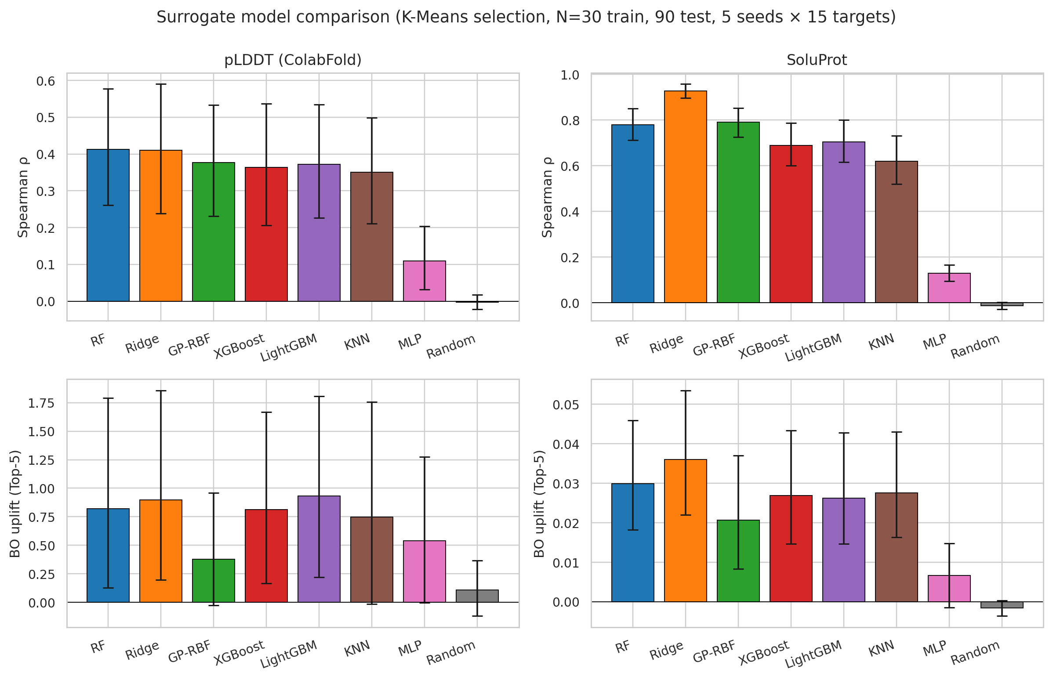
Model comparison
Figure 5. Eight surrogate models (RF, Ridge, GP-RBF, XGBoost, LightGBM, KNN, MLP, Random) compared on Spearman rho and BO uplift Top-5 for both pLDDT and SoluProt prediction. K-means training-set selection, N = 30, 90-sample held-out pool, 5 seeds x 15 targets = 75 paired observations. Error bars are 95% cluster bootstrap CIs.
Model | BO uplift Top-5 | Delta vs RF | p_holm vs RF | Cliff’s delta
LightGBM | 0.933 | +0.111 | 1.00 (n.s.) | +0.06
Ridge | 0.898 | +0.076 | 1.00 (n.s.) | -0.01
RF | 0.822 | - | - | -
XGBoost | 0.813 | -0.009 | 1.00 (n.s.) | +0.06
KNN | 0.747 | -0.075 | 1.00 (n.s.) | +0.07
MLP | 0.539 | -0.283 | 0.0008*** | +0.30
GP-RBF | 0.377 | -0.445 | 0.0020** | +0.18
Random | 0.109 | -0.713 | 0.0001*** | +0.42
Table 2. pLDDT BO uplift Top-5 under K-means selection at N = 30. Holm-corrected paired Wilcoxon places RF in a five-way statistical tie with LightGBM, Ridge, XGBoost, and KNN (p_holm = 1.00, |Cliff’s delta| <= 0.07). MLP, GP-RBF, and the random baseline are significantly worse (p_holm < 0.01).
Ridge is the strongest model for SoluProt-related metrics and wins five of eight production-quality metrics when pLDDT and SoluProt targets are considered together (Table 3). This supports score-specific defaults rather than a single universally best surrogate. In the implemented evolution loop, however, SoluProt is directly scored for all candidates; the local surrogate is used for the AF2-derived pLDDT bottleneck.
Metric (K-means, N = 30) | 1st | 2nd | RF rank
pLDDT - BO uplift Top-5 | LightGBM 0.933 | Ridge 0.898 | 3rd (0.822)
pLDDT - Top-5 recall | Ridge 0.269 | RF 0.219 | 2nd
pLDDT - Top-20 recall | Ridge 0.479 | RF 0.431 | 2nd
pLDDT - Spearman rho | RF 0.412 | Ridge 0.410 | 1st (tied)
SoluProt - Spearman rho | Ridge 0.926 | GP-RBF 0.791 | 3rd (0.780)
SoluProt - Top-5 recall | Ridge 0.747 | RF 0.555 | 2nd
SoluProt - Top-20 recall | Ridge 0.847 | RF 0.735 | 2nd
SoluProt - BO uplift Top-5 | Ridge 0.036 | RF 0.030 | 2nd
Table 3. Best models across pLDDT and SoluProt production-quality metrics. Ridge wins outright on five of eight metrics and ties RF on a sixth (pLDDT Spearman). LightGBM wins one (pLDDT BO uplift Top-5). RF is never first alone but is consistently in the top three. The means differ, but the Holm-corrected paired Wilcoxon comparisons against RF on the primary pLDDT BO uplift metric (Table 2) do not reach significance for any of these top models (p_holm = 1.00; |Cliff’s delta| <= 0.07).
This produces a deliberate three-way recommendation rather than a single winner:
- For pLDDT BO uplift, the active-learning loop’s target metric, LightGBM (0.933) or Ridge (0.898) outperform RF (0.822) by 14% and 9% in the mean.
- For SoluProt and developability metrics, Ridge dominates by a wide absolute margin (Spearman 0.926 vs RF 0.780; BO uplift 0.036 vs 0.030).
- For a single robust default across multiple surrogate targets and unknown future score functions, RF remains defensible: it is the only model that simultaneously ranks at or above third on every metric in Table 3 and shows near-zero hyperparameter sensitivity at small N.

4.4 Ensembles Do Not Improve the Best Single Model
Rank-mean, score-mean, and top-5 vote ensembles were evaluated over RF, Ridge, LightGBM, and XGBoost. Rank-mean is the strongest ensemble and is competitive with Ridge on pLDDT, but no ensemble exceeds the best single model on either pLDDT or SoluProt (Table 4). The ensemble also does not improve Top-10 sequence diversity, suggesting that the constituent models select similar regions of ESM space.
Combination rule | pLDDT BO uplift Top-5 | SoluProt BO uplift Top-5 | Top-10 internal identity (pLDDT)
LightGBM (best single, pLDDT) | 1.000 | 0.0328 | 0.888
Ridge (best single, SoluProt) | 0.962 | 0.0450 | 0.879
rank-mean ensemble | 0.961 | 0.0400 | 0.889
score-mean ensemble | 0.920 | 0.0412 | 0.888
top-5 vote ensemble | 0.928 | 0.0392 | 0.888
RF | 0.881 | 0.0373 | 0.897
XGBoost | 0.872 | 0.0336 | 0.885
Table 4. Four-model ensembles compared with single surrogate models on the same 15-target x 5-seed protocol (n = 70 paired observations per row). Rank-mean is the strongest ensemble and ties Ridge on pLDDT (0.961 vs 0.962); none of the three ensembles beats the best single model on either surrogate target. Bias metrics show ensembles do not diversify the picks: Top-10 internal identity (~0.888) is essentially the same as the best single model and worse than Ridge alone (0.879).
The ensemble result is empirically inconclusive: rank-averaging is competitive with the best single model on pLDDT (within noise of Ridge) and clearly beats RF and XGBoost, but it does not surpass Ridge or LightGBM, and it does not narrow the diversity-loss gap discussed in Section 4.5. Averaging four models does not give “the best of all worlds” here because the constituent models attend to similar features in ESM space and disagree most where they are individually weakest.
The ensemble option is nevertheless retained in the production loop for two operational reasons. First, robustness to per-target ranking flips: the means in Table 4 hide a per-target lottery in which the winning single model varies across CATH topologies, so rank-mean aggregation is retained as a hedge against choosing the wrong single model for a new target. Second, forward compatibility: when future surrogate families are added (e.g., neural surrogates trained on extended CATH data), extending the ensemble member list is a one-line configuration change, and the interface absorbs new models without committing the platform to a single new winner. The recommended deployment therefore stays target-aware: Ridge for SoluProt, LightGBM or Ridge for pLDDT, RF as the conservative multi-objective default, and the rank-mean ensemble when robustness matters more than peak performance.

4.5 Training-Set Diversity Does Not Remove Acquisition Bias
The surrogate’s Top-K selections can be more self-similar than the true Top-K, even when the training set is selected by K-means. We quantify this with overfitting identity to the best training sequence and internal identity within the selected Top-K (Figure 6, Table 5). K-means improves mean pLDDT but does not close the diversity gap by more than 0.3 percentage points. Diversity control therefore belongs at acquisition time, not only at training-set construction.
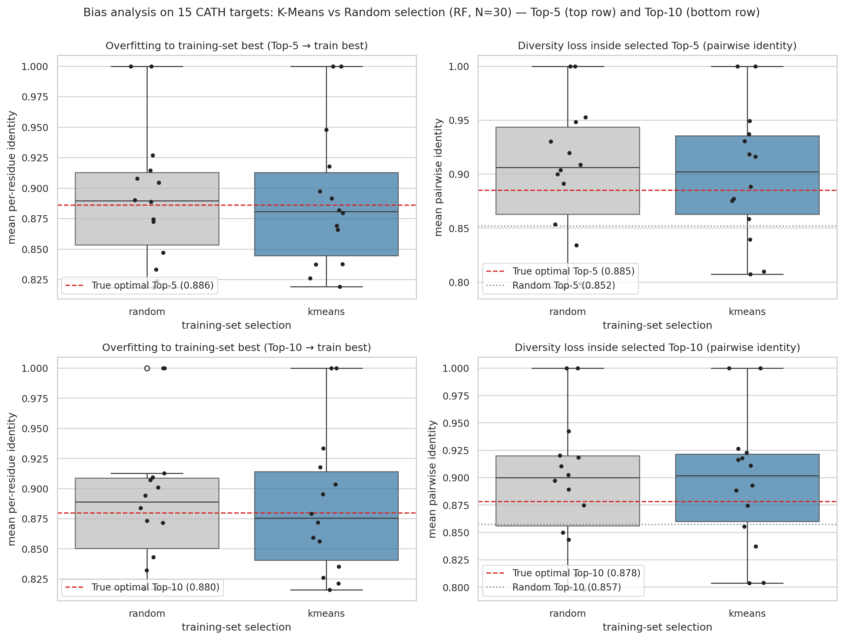
Bias analysis
Figure 6. Bias and diversity analysis on the 15-target pilot (RF, N = 30). Top row: Top-5 metrics; bottom row: Top-10 metrics. Box plots aggregate per-target means across 5 seeds; red dashed lines mark the true-optimal reference; right panels additionally show the random-baseline diversity floor.
Metric (15 targets x 5 seeds, RF, N = 30) | Random | K-means | True optimal | Random Top-K
Top-5 - overfit identity | 0.893 | 0.891 | 0.884 | -
Top-5 - internal identity | 0.903 | 0.901 | 0.887 | 0.846-0.858
Top-5 - mean pLDDT | 82.92 | 83.08 | 84.50 | ~82.0
Top-10 - overfit identity | 0.890 | 0.887 | 0.878 | -
Top-10 - internal identity | 0.897 | 0.897 | 0.879 | 0.855
Top-10 - mean pLDDT | 82.82 | 82.98 | 84.07 | 82.15
Table 5. Bias metrics on 15 CATH targets at K in {5, 10}. The same pattern holds at both K values: RF’s chosen Top-K sits about 1 percentage point closer to the training-set best than the true-optimal Top-K does (overfitting), and 1.5-2 percentage points more self-similar than the true-optimal Top-K (diversity loss). K-means selection narrows neither gap by more than 0.3 pp on this dataset, although it does lift the absolute pLDDT of the chosen Top-K by +0.15 over random sampling. The conclusion is robust to the choice of K.
Per-target results also show winner switching across surrogate families (Figure 7). This supports retaining several surrogate options rather than hard-coding one model family for all targets.
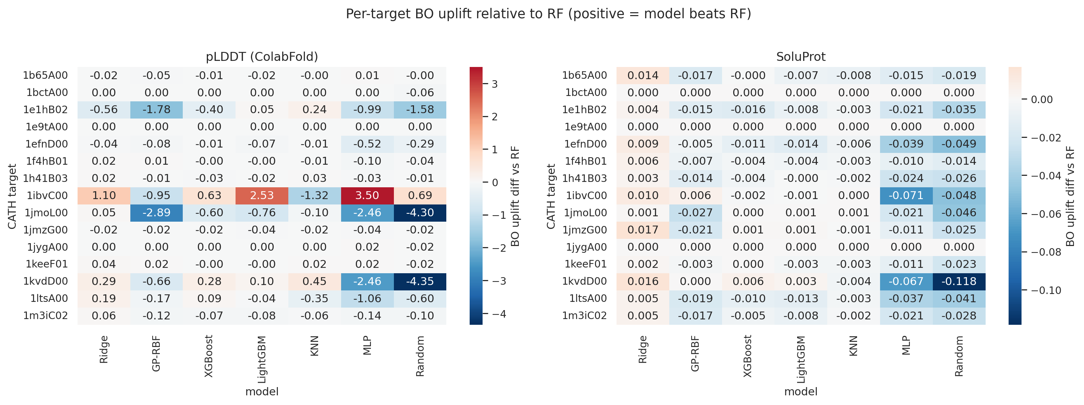
Per-target heatmap
Figure 7. Per-target BO uplift Top-5 difference relative to RF, K-means selection, N = 30. Each cell shows mean(model BO uplift) - mean(RF BO uplift) for one (target, model) pair, averaged over 5 seeds. Positive (red) values mean the model beats RF on that target; negative (blue) values mean the model loses. The heatmap exposes target-level winner switching that the aggregate Table 2 numbers hide: no single non-RF model dominates RF across all 15 targets, which is why RF, Ridge, LightGBM, and the four-model ensemble are all retained as production options - the per-target winner depends on the target’s location in ESM embedding space, not on the model alone.

4.6 Sample Size and Embedding Size
The sample-size ablation places the production default N = 30 on the cost-efficient plateau (Figure 8, Table 6). Increasing N from 30 to 80 requires roughly 2.7x more AF2-labelled training examples but yields only +25% pLDDT uplift and +9% SoluProt uplift relative to the N = 30 operating point.
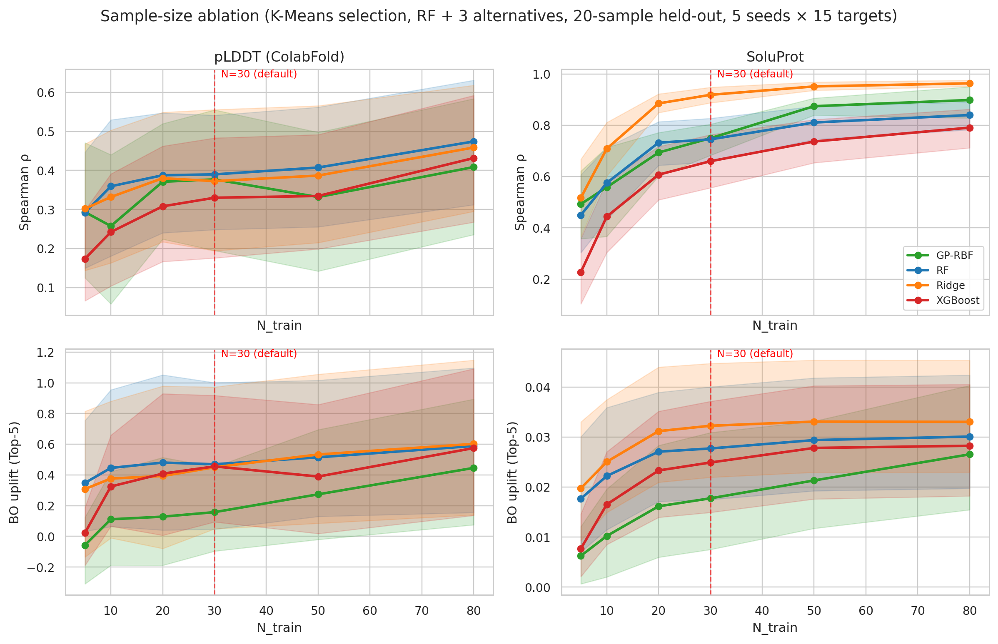
Sample size
Figure 8. N-ablation under K-means selection. Four models (RF, GP-RBF, Ridge, XGBoost) on Spearman rho and BO uplift Top-5 for both surrogate targets, with a vertical line at N = 30 (production default).
N_train | RF BO uplift Top-5 (pLDDT) | % of N = 80 | RF BO uplift Top-5 (SoluProt) | % of N = 80
5 | 0.348 | 59.1% | 0.0177 | 58.7%
10 | 0.446 | 75.7% | 0.0222 | 73.8%
20 | 0.481 | 81.6% | 0.0271 | 90.0%
30 (production and benchmark default) | 0.470 | 79.8% | 0.0277 | 92.1%
50 | 0.515 | 87.5% | 0.0294 | 97.7%
80 | 0.589 | 100.0% | 0.0301 | 100.0%
Table 6. Sample-size ablation for the RF surrogate under K-means selection. The N-ablation captures the diminishing-returns regime above N = 30: going from N = 30 to N = 80 spends 2.7x more AF2 evaluations to gain only +25% pLDDT uplift and +9% SoluProt uplift. The N = 30 default is therefore a deliberately conservative cost-efficient operating point.
We also compared ESM-2 8M (320-D) against ESM-2 150M (640-D) at fixed N = 30 (Figure 9). Differences in Spearman rho, Top-5 recall, and BO uplift Top-5 were not statistically significant for either pLDDT or SoluProt (Holm-corrected paired Wilcoxon p >= 0.5). The smaller embedding model is retained because it is faster at indistinguishable benchmark quality.
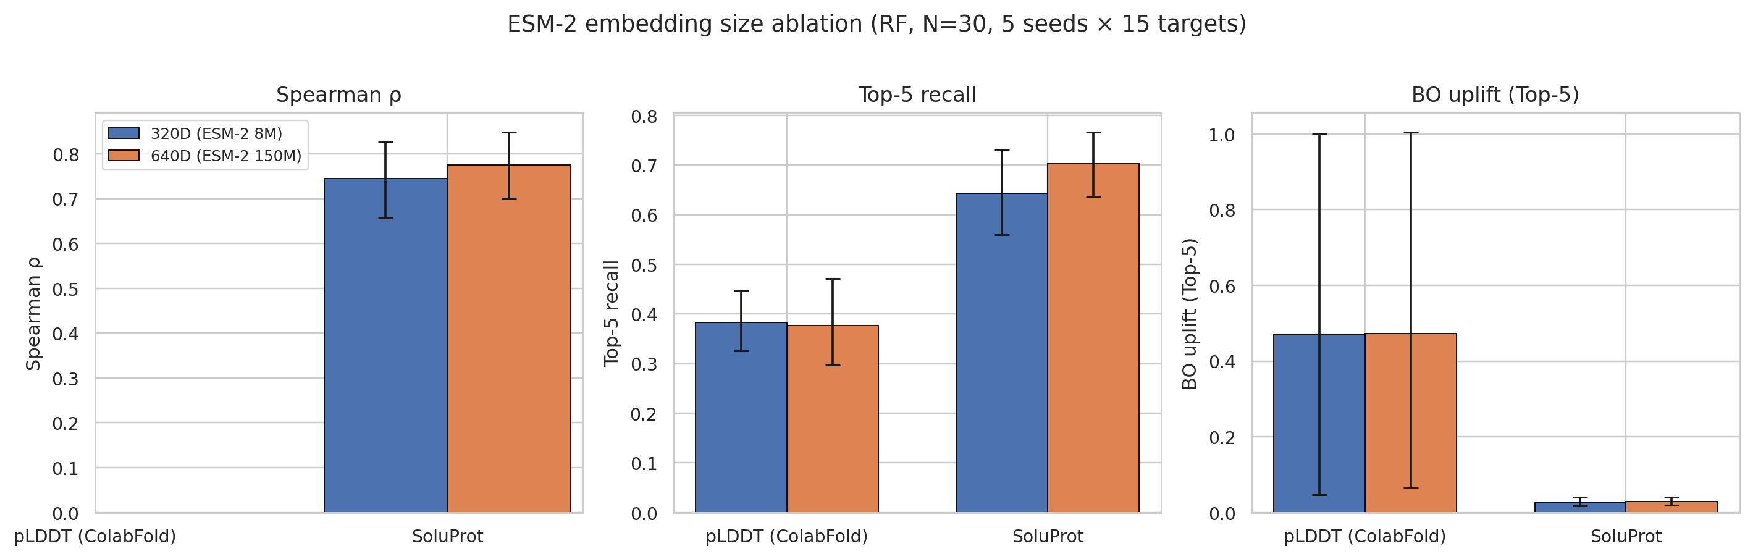
ESM size ablation
Figure 9. ESM embedding size ablation (RF, N = 30, K-means selection, 5 seeds x 15 targets). 320-D vs 640-D for both surrogate targets across Spearman rho, Top-5 recall, and BO uplift Top-5. Error bars are 95% cluster bootstrap CIs. None of the six paired comparisons reaches significance under paired Wilcoxon (p_holm >= 0.5).

4.7 Target Identity Dominates Observed Design-Quality Variance (Q3)
The final analysis asks whether low design scores mainly reflect ProteinMPNN sampling noise or the target/backbone context. A one-way ANOVA over the 1,766 AF2-evaluated designs shows that target identity explains nearly all of the observed pLDDT variance (Figure 10, Table 7). The ICC1 is 0.996 for pLDDT and 0.978 for SoluProt.
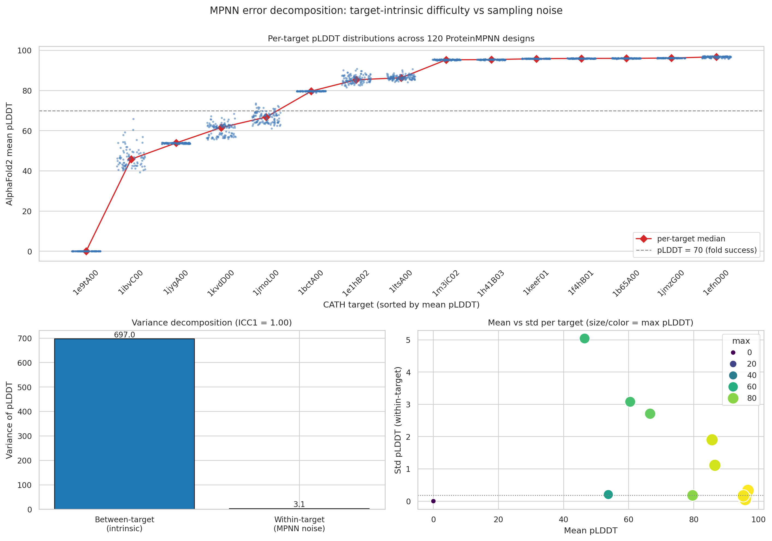
MPNN error decomposition
Figure 10. Per-target pLDDT distributions across 120 ProteinMPNN designs each (top, sorted by mean), variance decomposition (bottom-left), and per-target mean-versus-std scatter (bottom-right, marker size encodes max pLDDT). Targets are tightly clustered around their own mean and stretched far apart from each other.
Surrogate target | Between-target variance | Within-target variance | ICC1
pLDDT | 697.0 | 3.13 | 0.996
SoluProt | 0.0366 | 0.00087 | 0.978
Table 7. Variance decomposition of design quality across 15 CATH targets. ICC1 ~ 1 means almost all of the spread between high- and low-scoring designs is explained by which target is chosen, not by which sequence ProteinMPNN happens to sample for that target.
This result does not prove that ProteinMPNN is globally optimal. A low within-target variance is also consistent with a model that makes the same systematic mistake repeatedly. The result instead identifies where additional sampling is least likely to help in this dataset: drawing more sequences from the same target has limited observed headroom compared with changing or triaging the target/backbone context.

4.8 Representative Multi-Round Evolution Runs
To verify that the multi-round mode executes as implemented rather than only as an offline benchmark abstraction, we ran two representative RFD3-enabled redesign targets through the production evolution path. Each run generated four round-specific candidate pools with 2,000 SoluProt-gated candidates per round. The 3RGK run used 30 K-means bootstrap AF2 labels and Top-K = 20; the 1LVM run used the same 30-label bootstrap and Top-K = 5. These runs are not treated as a new statistical benchmark because they involve two targets and different Top-K budgets. They instead provide an execution trace for the pool generation, SoluProt gating, ESM embedding, K-means bootstrap, local surrogate ranking, AF2 oracle evaluation, optional relax scoring, and final design selection path.
Target | Run ID | SoluProt-gated candidates | AF2 records | AF2 reduction vs folding all gated candidates | Top-K setting | Best round/phase | Best SoluProt | Best pLDDT | Best relax score
3RGK | pys74631_kribb.re.kr_ev_3rgk | 8,000 | 94 | 98.8% | 20 | R1 train | 0.794 | 97.05 | -3.13
1LVM | admin_20260430_064926_afb67369 | 8,000 | 49 | 99.4% | 5 | R3 top-k | 0.734 | 89.52 | -3.15
Table 8. Representative end-to-end multi-round evolution runs. The AF2 reduction is computed as 1 - actual AF2 records / SoluProt-gated candidates. The two runs used different Top-K budgets, so the table demonstrates implemented orchestration and artifact capture rather than a paired biological comparison.
The companion direct pipeline runs (pys74631_kribb.re.kr_3rgk and admin_1lvm) each produced 60 SoluProt-scored candidates and 59 usable AF2 outputs after the RFD3/ProteinMPNN/SoluProt path. The 3RGK direct run reached mean pLDDT 96.33 and maximum SoluProt 0.866, whereas the 1LVM direct run reached mean pLDDT 88.85 and maximum SoluProt 0.772. These direct runs confirm that the same target-specific operating regimes appear in the standard pipeline path, but they are smaller than the multi-round evolution pools.
The two evolution traces also show why the multi-round result should be interpreted cautiously. In 3RGK, the best composite design was already present in the round-1 bootstrap training set, so later surrogate-guided rounds did not improve the selected best design even though they continued to find high-pLDDT candidates. In 1LVM, the best design was selected during the round-3 Top-K phase, demonstrating that archived surrogate reuse can identify later-round candidates. This supports the implementation claim, but a larger paired campaign is still needed to estimate hit-rate improvement.

5. Discussion

5.1 Solubility-Aware Pipeline as an Empirical Instrument
The pipeline preserves enough structure to make solubility-aware compute-allocation questions testable. Because every stage writes run-scoped artifacts under a typed contract, every result in Sections 4.2-4.7 was derived from the same 1,766 stored AF2 outputs and their corresponding SoluProt records using the same parsing code. The curated CATH expansion archive now adds 23 publication-grade targets with 2,737 valid paired SoluProt/pLDDT records. The limitation is therefore no longer simply the availability of run artifacts, but the need to rerun the full statistical and embedding pipeline on the curated expansion corpus. A model-replacement study - for example, swapping AF2 for ESMFold or AlphaFold3, ProteinMPNN for LigandMPNN/SolubleMPNN, or SoluProt for another solubility predictor - reduces to changing the backend that writes the relevant artifact fields rather than rewriting the analysis code. Table 9 maps this directly against the operations a script-based workflow would have to repeat or rewrite per ablation.
Operation | Script-based workflow | protein_pipeline
Add a new surrogate comparison | Re-load AF2 outputs from heterogeneous folders, write a new parser | Reload stored outputs from the typed af2/ artifact
Compare N in {5, …, 80} | Re-run pipeline per N or maintain custom subsampling scripts | Subsample the stored training pool
Swap AF2 -> AF3 / ESMFold | Rewrite scoring, parsing, and downstream filtering | Replace the structure-prediction backend; analysis code unchanged
Swap SoluProt -> another solubility model | Rebuild thresholding and result collation scripts | Replace the soluble-expression artifact writer; downstream ranking unchanged
Add a new metric retrospectively | Re-run scoring on each historical run | Compute on stored artifacts using the same contract
Reproduce a 6-month-old run | Hope the relevant folders, environment, and scripts survived | Open the run_id directory; request.json reconstructs the configuration
Cross-run comparison (15 targets x 5 seeds) | Manual collation across folders, brittle to schema drift | Same artifact schema guarantees direct comparison
Table 9. Operational contrast between a script-based workflow and protein_pipeline on the operations performed in Section 4. The artifact contract is what allows the same 1,766 AF2 outputs to support six independent ablations without re-folding or per-experiment parser rewrites, and it is also what allows the expanded CATH archive to be indexed and QC-filtered by the same schema.

5.2 AF2 Budget Model
The implemented active-learning loop uses approximately 50 AF2 calls in the bootstrap round rather than folding every candidate in a 90-candidate SoluProt-gated pool. For a multi-round campaign, Table 10 gives the implemented orchestration-level budget: the first round bootstraps the surrogate, and later rounds reuse the archived local expert and evaluate only the surrogate-ranked Top-K candidates. Under this model, a four-round campaign spends 110 AF2 calls rather than 360, a 69% reduction. At an assumed 30 seconds per AF2 call on the production endpoint, this corresponds to approximately 55 minutes rather than 180 minutes of GPU time per target.
Per-round AF2 budget model | Without surrogate | Round 1 (with surrogate) | Rounds 2-4 (label reuse / archived expert)
AF2 evaluations | 90 | 30 + 20 = 50 | 20
Reduction vs no-surrogate | - | 44% | 78%
Table 10. AF2 budget per round on a 90-candidate SoluProt-gated pool. Round 1 evaluates 30 K-means training candidates and 20 surrogate-selected candidates (50 total); rounds 2-4 reuse the trained surrogate and only evaluate the 20 top-ranked candidates each. Across a four-round campaign the total AF2 budget is 50 + 20 x 3 = 110 evaluations versus 90 x 4 = 360 without the surrogate, a 69% overall reduction.
The representative 3RGK and 1LVM evolution runs in Section 4.8 use larger RFD3-enabled pools than the 90-candidate budget illustration, with 8,000 SoluProt-gated candidates per target. Their realized AF2 records were 94 and 49, respectively, because only the bootstrap and surrogate-selected candidates are sent to the oracle. These runs validate the implemented execution path and artifact capture; a larger paired campaign remains necessary to estimate biological hit-rate improvement from archived expert reuse.

5.3 Compute Allocation Across Backbones
The variance decomposition changes the interpretation of the active-learning loop. If most observed variance were within a target, deeper ProteinMPNN sampling or a better acquisition rule would be the main compute lever. Instead, target identity explains 99.6% of pLDDT variance in this benchmark. This suggests that early rounds should allocate some budget to target or backbone triage rather than only to more sequence variants around one backbone. RFdiffusion and BioEmu are therefore not simply optional generative additions; they are operational levers for exploring the dominant variance axis.
Within a chosen backbone, conservation-tier sampling remains useful, but the observed within-target spread bounds its expected return. Acquisition-time diversity control is still needed because the surrogate’s selected Top-K is more self-similar than the true optimum. These two conclusions are complementary: backbone or target triage addresses the largest observed variance axis, while acquisition diversity prevents local surrogate selections from collapsing within a promising context.

5.4 Re-validation After Model Replacement
The benchmark results should be interpreted as estimates for the current solubility-aware model stack, not as invariant statements about all future structure predictors, inverse-folding models, or solubility predictors. The pipeline design makes this limitation manageable. If a replacement structure predictor such as ESMFold or AlphaFold3, a replacement inverse-folding model such as LigandMPNN or SolubleMPNN, or a replacement solubility/developability model writes the same artifact fields, the same benchmark protocol can be rerun. The numerical operating point may change, but the analysis workflow does not need to be redesigned.

6. Limitations
- Benchmark freeze versus expanded archive. The reported statistical comparisons use the frozen 15-target benchmark so that all tables, figures, ESM embeddings, and paired tests refer to one consistent analysis set. The curated CATH expansion set contains 23 publication-grade targets after excluding fallback or input-incompatible runs. The full surrogate comparison and figure set still need to be regenerated on this curated expansion corpus before replacing the frozen benchmark numbers.
- Solubility scope. The pipeline is designed and benchmarked as a solubility-aware redesign/library-generation workflow. Binder design, enzyme active-site redesign, and fully de novo protein generation are supported only through optional or replaceable stages and are not validated as primary claims here.
- Component-level validation. The active-learning benchmark evaluates surrogate selection from stored SoluProt/AF2 candidate pools, not a complete wet-lab campaign. Two representative multi-round runs validate end-to-end orchestration, but campaign-level hit-rate improvement and wet-lab outcomes from archived expert reuse remain to be validated.
- Computational proxies. pLDDT and SoluProt are computational proxies. Experimental expression, stability, and activity measurements are required before claiming physical design success.
- Rosetta Relax coverage. Relax scores are not available for the full pilot artifact set, so the structural-confidence versus energy Pareto frontier is not analysed.
- Agent evaluation. Literature-driven masking and Gemini-based reasoning are operational components of the platform but are not quantitatively benchmarked here.
- Model replacement not yet demonstrated. The architecture supports model replacement by artifact contract, and the QC-filtered CATH expansion corpus reduces the data-availability barrier for such a study, but the benchmark has not yet been rerun with AlphaFold3, ESMFold, LigandMPNN, or another replacement backend.

7. Conclusion
protein_pipeline addresses a practical gap between rapidly improving protein-design models and the reproducible infrastructure needed to use them in solubility-aware redesign campaigns. The pipeline preserves run-scoped artifacts, supports controlled partial reruns, exposes the workflow through a packageable static web interface and backend API, and keeps model interfaces replaceable. On top of this infrastructure, a local active-learning module reduces AF2 usage by labelling a small K-means-selected training set, fitting a surrogate, and folding only the surrogate’s top-ranked SoluProt-passing candidates.
The empirical benchmark shows that K-means selection improves small-N surrogate performance, that surrogate choice is score-dependent, and that a 20-30 example training set is a cost-efficient operating point. The variance decomposition further shows that target identity, not ProteinMPNN sampling noise, dominates observed pLDDT variance in the frozen benchmark set. The QC-filtered CATH expansion corpus gives the same workflow a larger basis for re-analysis and model-replacement tests without treating fallback records as valid design failures. These results support a compute policy in which SoluProt is used as the fast soluble-expression gate, AF2 is reserved for informative structurally plausible short lists, and early campaign budget is allocated across target or backbone contexts rather than only to deeper sequence sampling within one backbone. The pipeline’s artifact contract makes these conclusions re-testable as the underlying generative, solubility-prediction, and structure-prediction models change.

Code, Data, and Software Availability
The pipeline implementation, benchmark scripts, generated figures, result tables, representative multi-round case-study summaries, and static web interface are organised in a public-release package. The backend/MCP service is under pipeline-mcp/, the static browser interface is under frontend/, benchmark scripts are under scripts/benchmark/, generated figures are under figures/benchmark/, tabular benchmark results are under data/benchmark/results/, and representative 3RGK/1LVM execution summaries are under data/case_studies/. The expanded CATH corpus is staged locally under cath_outputs/; the publication-grade subset and QC reports are under cath_outputs/paper_curated/. Because the full corpus is several gigabytes, it should be archived as a large release artifact or S3-backed dataset rather than committed directly to a lightweight GitHub source tree. The release documentation also records the Docker Hub images used to instantiate the RunPod endpoints for MMseqs2, ProteinMPNN, ColabFold/AF2, RFD3, BioEmu, and Rosetta Relax. The included .env.example documents required RunPod endpoint variables and local/OIDC authentication settings; filled .env files, endpoint IDs, API keys, and runtime logs are excluded. The manuscript uses stored benchmark artifacts rather than modifying generated result values. For publication, the GitHub release should be archived with a persistent DOI, and the same archive should contain the benchmark data used to regenerate the reported tables and figures.

References
[1] Dauparas, J., Anishchenko, I., Bennett, N., et al. (2022). Robust deep learning-based protein sequence design using ProteinMPNN. Science. doi:10.1126/science.add2187
[2] Jumper, J., Evans, R., Pritzel, A., et al. (2021). Highly accurate protein structure prediction with AlphaFold. Nature. doi:10.1038/s41586-021-03819-2
[3] Mirdita, M., Schutze, K., Moriwaki, Y., Heo, L., Ovchinnikov, S., & Steinegger, M. (2022). ColabFold: making protein folding accessible to all. Nature Methods. doi:10.1038/s41592-022-01488-1
[4] Lin, Z., Akin, H., Rao, R., et al. (2023). Evolutionary-scale prediction of atomic-level protein structure with a language model. Science. doi:10.1126/science.ade2574
[5] Watson, J. L., Juergens, D., Bennett, N. R., et al. (2023). De novo design of protein structure and function with RFdiffusion. Nature. doi:10.1038/s41586-023-06415-8
[6] Lewis, S., Hempel, T., Jimenez-Luna, J., et al. (2025). Scalable emulation of protein equilibrium ensembles with generative deep learning. Science. doi:10.1126/science.adv9817
[7] Hon, J., Marusiak, M., Martinek, T., Kunka, A., Zendulka, J., Bednar, D., & Damborsky, J. (2021). SoluProt: prediction of soluble protein expression in Escherichia coli. Bioinformatics. doi:10.1093/bioinformatics/btaa1102
[8] Steinegger, M., & Soding, J. (2017). MMseqs2 enables sensitive protein sequence searching for the analysis of massive data sets. Nature Biotechnology. doi:10.1038/nbt.3988
[9] Goldenzweig, A., Goldsmith, M., Hill, S. E., et al. (2016). Automated structure- and sequence-based design of proteins for high bacterial expression and stability. Molecular Cell. doi:10.1016/j.molcel.2016.06.012
[10] Kosugi, T., & Ohue, M. (2022). Solubility-Aware Protein Binding Peptide Design Using AlphaFold. Biomedicines. doi:10.3390/biomedicines10071626
[11] Fleishman, S. J., Leaver-Fay, A., Corn, J. E., et al. (2011). RosettaScripts: A scripting language interface to the Rosetta macromolecular modeling suite. PLOS ONE. doi:10.1371/journal.pone.0020161
[12] Jiang, K., Yan, Z., Di Bernardo, M., et al. (2025). Rapid in silico directed evolution by a protein language model with EVOLVEpro. Science. doi:10.1126/science.adr6006
[13] Model Context Protocol Contributors (2024). Model Context Protocol Specification. https://modelcontextprotocol.io/specification/2024-11-05/index
[14] Conway, P., Tyka, M. D., DiMaio, F., Konerding, D. E., & Baker, D. (2014). Relaxation of backbone bond geometry improves protein energy landscape modeling. Protein Science. doi:10.1002/pro.2389
[15] Sillitoe, I., Bordin, N., Dawson, N., et al. (2021). CATH: increased structural coverage of functional space. Nucleic Acids Research. doi:10.1093/nar/gkaa1079
[16] Breiman, L. (2001). Random Forests. Machine Learning. doi:10.1023/A:1010933404324
[17] Chen, T., & Guestrin, C. (2016). XGBoost: A Scalable Tree Boosting System. Proceedings of the 22nd ACM SIGKDD International Conference on Knowledge Discovery and Data Mining. doi:10.1145/2939672.2939785
[18] Ke, G., Meng, Q., Finley, T., Wang, T., Chen, W., Ma, W., Ye, Q., & Liu, T.-Y. (2017). LightGBM: A Highly Efficient Gradient Boosting Decision Tree. Advances in Neural Information Processing Systems 30. https://papers.nips.cc/paper/6907-lightgbm-a-highly-efficient-gradient-boosting-decision-tree
[19] Pedregosa, F., Varoquaux, G., Gramfort, A., et al. (2011). Scikit-learn: Machine Learning in Python. Journal of Machine Learning Research. https://www.jmlr.org/papers/v12/pedregosa11a.html
[20] Arthur, D., & Vassilvitskii, S. (2007). k-means++: The Advantages of Careful Seeding. Proceedings of the Eighteenth Annual ACM-SIAM Symposium on Discrete Algorithms. https://dl.acm.org/doi/10.5555/1283383.1283494
[21] Shahriari, B., Swersky, K., Wang, Z., Adams, R. P., & de Freitas, N. (2016). Taking the Human Out of the Loop: A Review of Bayesian Optimization. Proceedings of the IEEE. doi:10.1109/JPROC.2015.2494218
[22] Wilcoxon, F. (1945). Individual Comparisons by Ranking Methods. Biometrics Bulletin, 1(6), 80-83. doi:10.2307/3001968
[23] Holm, S. (1979). A Simple Sequentially Rejective Multiple Test Procedure. Scandinavian Journal of Statistics, 6(2), 65-70. https://www.jstor.org/stable/4615733
[24] Cliff, N. (1993). Dominance statistics: Ordinal analyses to answer ordinal questions. Psychological Bulletin. doi:10.1037/0033-2909.114.3.494
[25] Shrout, P. E., & Fleiss, J. L. (1979). Intraclass correlations: Uses in assessing rater reliability. Psychological Bulletin. doi:10.1037/0033-2909.86.2.420

